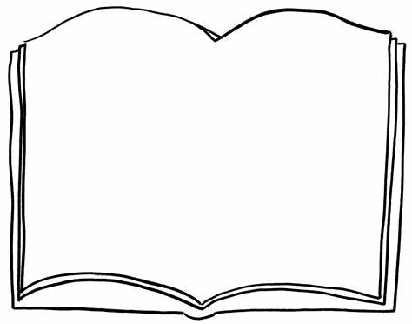

Preparation for Adulthood:

Autumn 1 & 2: Each week some students will be ordering ingredients or visiting the local shop, following a recipe and cooking our own lunch. We will experience a range of textures, tastes and smells as we learn different methods to cooking and baking.

PSHE/SRE:

Autumn 1: Me, My Friends and My Feelings. Exploring likes and dislikes, developing our own coats of arms, exploring our feelings and learning about events that could be important to our friends.

Autumn 2: Respecting others and developing positive relationships. Exploring and spending time with different people help us in different settings, e.g. the home, school, the community. Using our voices to build positive relationships in different ways, e.g. with personal care staff, physios etc.

Independence:

Autumn 1 & 2: We will be focusing on learning about and taking part in key life skills. All students will get the opportunity to take part in a range of activities across the term – working with different staff and peers across Key Stage 4. Some students will be learning how to do the washing up following cooking sessions. Some will also be visiting the new bedroom on site and learning how to make a bed, tidy up after ourselves and how to use the washing machine and clothes dryer.

PE:

Each week some students will be focussing on body awareness, sensory exploration and having fun whilst completing our individualised physio programmes and MATP (motor activity training programme). In Autumn 1 some students will be exploring basic fitness activities and developing key skills within them e.g. running and jumping. We will be exploring the impact of fitness on different events, and looking to explore technique.

In Autumn 2 some students will be learning about and practicing ball control, racquet technique, tactics and how to accurately score a game of tennis.

The World Around Us / ASDAN:

Autumn 1: We will be creating a class book that details our likes and dislikes for those who need to know. We will be exploring what different religious holy books teach about religious festivals (Rosh Hashana, Sukkot and Diwali) and developing our understanding of them through sensory means. We will also be having our weekly leisure option. Some students will also be thinking about how to keep ourselves online.

Autumn 2: We will be joining the local library and going on trips there to borrow and later return some books. The Christmas Market will provide us with an enterprise project opportunity, and the theme this year is Charles Dickens, ‘A Christmas Carol’. We will also be visiting some places of worship and experiencing how their Holy Books are important to them.

The Wonderful World of Books

Beech Class – KS4

Autumn 2022

STEM:

Autumn 1: This term, we will be learning about some differences and similarities between people in Beech class. We will also be learning about how we can decorate a room, and developing the sensory room in class as a practical way of doing this. We will be looking at books and catalogues for inspiration and ideas, and expressing preferences about what we would like in our space..

Autumn 2: We will be exploring recipe books and following instructions to craft, make and create products to sell at the Christmas Market, and presents to gift at the end of term.

Additional Adventures:

Throughout the term, some students will also be taking part in our therapies, positioning and additional sessions such as the White Room and Praxis Room, where appropriate. We will also be taking part in sensology, story massage, mindfulness, Attention

Autism and lots of music, amongst many other personalised adventures.

Expressive Arts:

Autumn 1: The Story of our Kelford Lives. ‘A picture is worth 1000 words.’ We will be exploring Sketchbooks and creating our own through exploring different types of art media to develop and enhance photos of us throughout their time at Kelford, e.g. pop art, scratch art, digital art, clay. This process will all be recorded in our own sketch book.

Autumn 2: We will be working as a class team towards a sensory Christmas production involving music and movement. It will develop over the weeks with the pupil’s interests and preferred experiences.

Communication and Functional Skills

Autumn 1: All learning will be focussing around our Sensory Story, ‘A Voyage to Arghan’ by Joanna Grace. We will be travelling around school to write our own book and retell our story of ‘Our Journey around Kelford’ through lots of sensory experiences. Some leaners will be following instructions, direction s and picture maps as they sequence their journey of adventures around school.

Autumn 2: All learning will focus around our sensory stories of ‘Alice in a Sensory Wonderland’, as we create our own sensory wonderland to explore, and later ‘The Magi’ in the lead up to Christmas as we explore their journey to Bethlehem. These stories will tie in with some students’ travel training as they access the local community using public transport and practise their speaking and listening skills with members of the public and reading and understanding timetables and money exchange.